LOGIN
Ability for different levels of login, allowing agency to see all their client info and client to only see their info
- Master Administrator (James) – all permissions
- Administrator (Kathi) – can see all clients data
- Agency – Can see clients under the Agency and a summary for agency
- Client – can only see client data and different campaigns under the client
Example: Agency: A to Z Communications
Client: Dunn Diamond Insurance Agency
Campaign: 2026-01 Families
Campaign: 2026-02 Empty Nesters
Campaign: 2026-03 Businesses
Agency: Prosecco Corporation
Client: NextGen Benefits Solutions
Campaign: 2026-01 Colorado Small Businesses
Client: Classic Air
Campaign: 2026-01Quick Turn and Hanger
Client: BPW
Campaign: 2026-01 Fall Recruitment Ads
REPORTING
Will require an API connection to Simplifi and possibly other platforms later – want to be able to have 24/7 access to the campaign data in Simplifi and also the reports used to identify leads
- Campaign Performance Report
  - API from Simplifi
  - Reports Impressions Delivered Clicks, and CTR (Click through rate) for all tactics within a campaign for a client
  - Example:
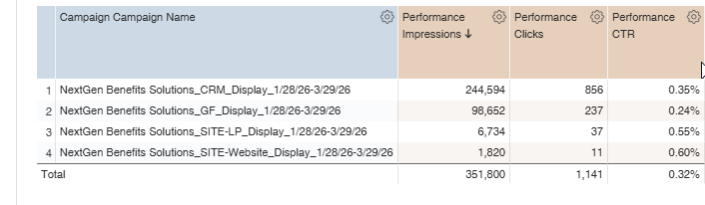
- ProspectPulse Lead Report (Map)
  - Heading:
    - Prospect Pulse Leads (not Ad clicker Matcher)
    - For reporting across top
      - Businesses Matched
      - Total Ads Delivered
      - Total Clicks
      - Total Touches
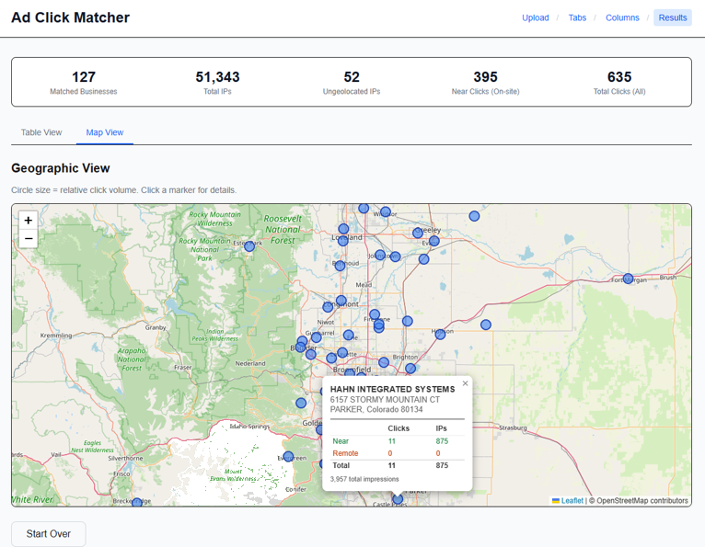
Then for the map, the business as you have it and then: Name and Address, Total Ads Delivered, Total Clicks, Total Touches, Lead Score – all but Lead Score will come in from API
- Lead Score: 1 to 121 (if 121 businesses matched)
  - Number of clicks on site retargeting tactics, 1 to however many, Calculate it by number of clicks on ads high to low and then score 1 to 45 (for example), then by number of clicks on tactics high to low (46 to 121)
  - I am open to thoughts here for this lead scoring

- ProspectPulse Lead Report
Matched businesses they can then use for calls, emails, etc.
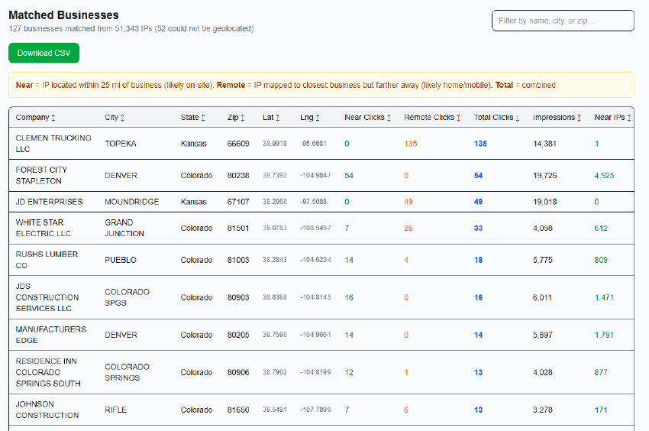

Report Format:
First Column: Check box – will allow the individual to check which ones they are interested in following up on
Subsequent Columns: Company, Address, City, State, Zip, Phone, Total Clicks, Ads Delivered

After checking the top five, can these be loaded into a Contact Database (new Tab At Top)
- Purpose is to allow the salesperson the ability to then use for contact and keep up with notes on each contact.

- ProspectPulse Lead Tracker
After they pull who they want to contact with the check marks, they then have a main screen that shows them their contacts – I assume you have a CRM plugin laying around somewhere lol

This needs two parts like the screen print below – ability to see status on all Leads
- Lead
- Qualified
- Proposal
- Negotiation
And the ability to pull detailed info on the lead – and add in name and contact info – and info about the contacts – when, format, outcome, etc.
See screen print below
- Prospect Plus Lead Follower
This needs to be a reminder section of who to contact when and in what way.
I assume we would add in text and email contacts or links at a later date?
